Managing a teaching-learning situation
Time Management
Trainer: Rabia El Antaki. CRMEF Tangier
English Department

Learning outcomes
By the end of the session, trainees will learn:
-The definition and the principles of classroom time management.
-The importance of efficient classroom time management in making the teaching experience more rewarding for teachers and the learning process more structured for learners.
-To Identify common classroom time management mistakes and their impact on the teaching/learning process.
How to implement various classroom time management stategies to use time wisely and effectively.
By the end of the session, trainees will:
-Predict/deduce/discuss
-Reflect on questions and issues related to classroom time management
-Devise time management techniques and strategies.
Reflection questions:
- What does classroom time management mean
- Why is time management crucial to successful learning experiences?
Read the following article and do the tasks below
Article : https://www.timemanagementforteacher.com/Time_Management_For_Teachers_files/Time%20Management%20for%20Teachers%20PREVIEW%20Pages.pdf

Task 1 : Complete the following chart
Time management problems | Possible causes | Appropriate Responses
you still have time left
you finished the lesson and students did not understand
you run out of time
Some students are time wasters
There are many things to do at the same time and you feel overwhelmed

Task 2
Provide 5 useful time management strategies (and explain each one) that would save time and provide an environment conducive to efficient learning
- -----------------------------------------------------------------------------------------------------------------------------------------------------------------------------------------------------------------------------------------------------------------------------------------------------------------------
- -----------------------------------------------------------------------------------------------------------------------------------------------------------------------------------------------------------------------------------------------------------------------------------------------------------------------
- -----------------------------------------------------------------------------------------------------------------------------------------------------------------------------------------------------------------------------------------------------------------------------------------------------------------------
- -----------------------------------------------------------------------------------------------------------------------------------------------------------------------------------------------------------------------------------------------------------------------------------------------------------------------
- -----------------------------------------------------------------------------------------------------------------------------------------------------------------------------------------------------------------------------------------------------------------------------------------------------------------------

Task 3
Allocate the appropriate time for each of the following activities and provide the rationale behind your choices
Suppose you have 90 mn to teach food vocabulary to a common core level.
Activities and Tasks | Time Alloted | Rationale
lead-in: Show SS a short video of a cooking show and allow for discussion to set the scene for the lesson
First Input : Use flashcards to introduce some food items. Show each flashcard one by one and elicit or teach the word. If your learners already know some food vocabulary, try revealing each picture slowly, by holding a blank piece of paper in front of the picture and slowly moving it to reveal the picture while the learners guess what it is
Controlled practice: Pair work. Provide SS with a worksheet and ask them to write the appropriate words under each food item. Pronounce in Chorus 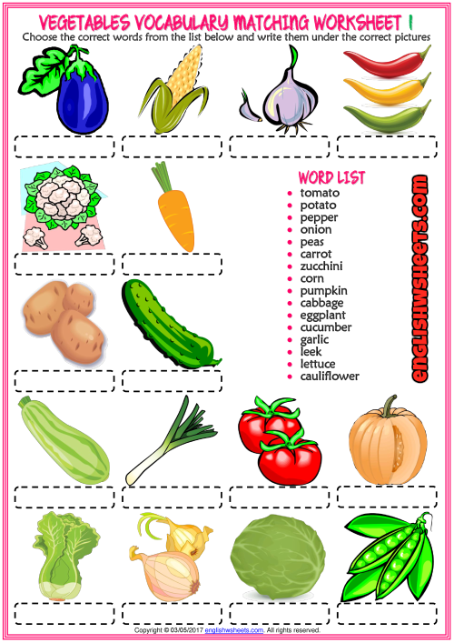
Guided Practice. Group Work. Dictogloss. You have to find (or write) a text including the food vocabulary SS studied. You dictate the text and the different groups have to reconstruct the text.
Free practice: Divide the class into groups and assign each group the task of writing the menu for their vegetarian restaurant.
Closure: Written exit ticket: SS can leave the classroom only if they provide you with 5 food items they studied and they like to eat

An example of the homework submitted by a trainee.
Hafsa El Yaichi : CRMEF Tangier
Task 1 : Complete the following chart
Time management problems | Possible causes | Appropriate Responses
you still have time left | - Implementing a few engaging activities or none of them and relying on lecturing;  - Explaining and speaking too fast. | - Implementing activities that give students the chance to speak and be engaged throughout the lesson instead of lecturing only.  - Maintaining a balanced speech pace, especially while tackling important points of the lesson.
you finished the lesson and students did not understand | - Students were provided with a lot of materials;  - Students were not given the chance to participate in the lesson.  - Too much difficult vocabulary that SS couldn’t understand and the teacher had no time to explain them. | - Provide the students with only the most important materials and when you feel that they understand them provide them with extra ones.  - Give SS the chance to engage in the lesson; let them deduce ideas by themselves from a given text and discuss ideas with their classmates. This way they can gain understanding better when they are engaged in the process of learning.  - Provide students with materials that adjust to their level of understanding and if there are some difficult words try to allocate a certain amount of time to explain them or let them deduce the meaning from the context by themselves.
you run out of time | - Spending too much time explaining trivial things that can be easily understood throughout the lesson;  - Trying to include a lot of activities in a short period of time; | - While explaining, put emphasis only on ideas that are difficult or of a high importance to the progress of the lesson.  - Try to make priorities concerning the activities intended in your lesson plan; do not stick to the lesson plan; start with the most important activities in each stage and introduce more activities if there is still time.
Some students are time wasters | - They are provided with uninteresting materials;  - Their misbehavior is not dealt with immediately. | - Try to cater for the different needs and preferences of the SS; provide them with audio-visual materials; and engage them in activities that entail movements to catch their attention and reduce their disruptive behaviors.  - Try to create a code of conduct in the beginning of each school year and stick to it; if there is any kind of misbehavior act immediately according to what was agreed on.
There are many things to do at the same time and you feel overwhelmed | This probably happen because of two main causes:  - Procrastination;  &  - Lack of organization | - Act immediately when you have something to do and most importantly prioritize the things you want to finish by their importance and do them due time.  - Put materials that you constantly need somewhere closer to your work place, your desk’s drawer for example; when you organize your files and materials according to their importance, you would be encouraged to finish your work as everything you want to use is easily accessed.

Task 2
Provide 5 useful time management strategies (and explain each one) that would save time and provide an environment conducive to efficient learning
- Careful planning of each session. It is a useful strategy to plan your session reasonably. Planning a session is not only about creating a lesson plan and allocating a certain time to each activity, but it has to do also with planning for smooth transitions between activities by making the transition clear and establishing routines for transition times to avoid the formation of vacuums which might lead to misbehavior. It is notable while planning to take into consideration the resources and materials that should be used and allocating an amount of time to collect and prepare them as well. Equally important, teachers should always expect some interruption during the lesson so they should keep some time for it.
- Getting organized. This strategy is key to time management. Good organization can be achieved through keeping a daily planner, diary or calendar as a reminder for all to-do lists. Additionally, to avoid wasting too much time looking for files and materials, it is important to organize the desk and the filing system by keeping your desk neat and clean, putting the most important working files and materials within arm’s reach, and making use of the computer to save your files in different categories for easier access.
- Avoiding procrastination. Procrastination is a great time waster. Teachers should avoid delaying their work to later times and make commitment to take action as soon as there is a work to be done. We should create a list of work according to priority and avoid doing tasks of less importance until we finish the most important once. In fact, it is argued that setting up a system of rewards works greatly in motivating people to accomplish their work on time.
- Avoid being workaholic. Teachers should not accept any extra work that is beyond their power. When we tend to work too much we get overwhelmed and confused and we probably end up doing none of the tasks we intended to do even the simplest ones. Hence, we should prioritize our own commitments and responsibilities and not accept any additional responsibility and simply turn down any request, project or invitation by other colleagues or the administration if we know it will be more than hard to carry out.
- Assign students some classroom responsibilities. It may sound as a trivial strategy, but through assigning students to do some simple tasks; we can save a huge amount of time. Through this strategy we can assign a student to be responsible for collecting students’ work, another one for distributing them, and a student to be a classroom greeter, who greets any classroom visitor whenever someone knocks at the door to avoid interrupting the lesson. It is a helpful strategy that does not only save classroom time, but creates a sense of confidence in the learners as well.
Task 3
Allocate the appropriate time for each of the following activities and provide the rationale behind your choices
Suppose you have 90 mn to teach food vocabulary to a common core level.
Activities and Tasks | Time Alloted | Rationale
lead-in: Show SS a short video of a cooking show and allow for discussion to set the scene for the lesson | 5min | The lead-in or the warm-up should, for the most of time, take only a few minutes. Here, the period of time allocated depends mainly on the length of the videotape. Thus, since we have a video recording, which may last for 2 min, the discussion which entails speaking and deducing; may take a little bit more time: 2/3 mn
First Input : Use flashcards to introduce some food items. Show each flashcard one by one and elicit or teach the word. If your learners already know some food vocabulary, try revealing each picture slowly, by holding a blank piece of paper in front of the picture and slowly moving it to reveal the picture while the learners guess what it is | 20min | The stage of presenting vocabulary for the first time always takes a lot of time. Moreover, since we need to elicit from the students words that they have never met or only some of them met, we need to give them a little bit time to think and if they failed to answer we can interrupt and provide them with the proper word.
Controlled practice: Pair work. Provide SS with a worksheet and ask them to write the appropriate words under each food item. Pronounce in Chorus | 15min | The activity of filling the blanks with the appropriate food item may last for 10min because we need to consider that it is the first activity that SS are given to practice the newly learned words and they need some time to discuss with each other. As for the second activity, it is mainly controlled fully by the teacher and he/she can stop whenever he/she feels that students are accustomed to pronouncing the words. In my opinion, it should not last more than 5min because choral drilling may be annoying to closer classes and it may raise some kind of misbehavior if it takes too much time.
Guided Practice. Group Work. Dictogloss. You have to find (or write) a text including the food vocabulary SS studied. You dictate the text and the different groups have to reconstruct the text. | 20min | Dictogloss is a very engaging kind of dictation through which students employ their four skills all together. Here, the amount of time allocated depends on the length of the text. So they should be given some time to discuss with each other the way they are going to work on the activity, giving them time to listen for the first time and jot down what they heard, then listen for another time to check their statements and for the third and the final one to provide the final original text.
Free practice: Divide the class into groups and assign each group the task of writing the menu for their vegetarian restaurant. | 25min | This activity may seem simple for some students, but we should consider that common core English students in Morocco are still beginners. That’s why we need to provide them with a reasonable amount of time in each activity especially in free practice stage because they work on their own with no prompts given. Hence, students should be given enough time to discuss and try to create a creative menu with some food drawings and to write down their final menu and present it.
Closure: Written exit ticket: SS can leave the classroom only if they provide you with 5 food items they studied and they like to eat | 5min | In this stage we should consider the different levels of students inside the classroom because although at this stage most of the students probably managed to learn many food items, some of them may still have difficulties especially in spelling the items correctly, meaning that some students can submit their exit ticket in a maximum of 2min, but you will always find in the class some slow learners that should be given more time to articulate the precise spelling of each item they want to write.

